1. **Generate a sine wave using a function**

* Write your own Matlab function GenSin(frequency, sampleRate, duration) to generate a unity amplitude sine wave signal.
* Note you need so save the function in its own file named GenSin.m and then call it from another script.
* To specify its output signal, pass it the parameters frequency, sampleRate and duration.
* Hint: Sensible values would be something like
* sampleRate = 1000Hz, frequency = 5Hz, duration=0.4s.
* Plot the data signals against time as shown below.
* Make sure you write a title, put on a plot legend and label the axes.

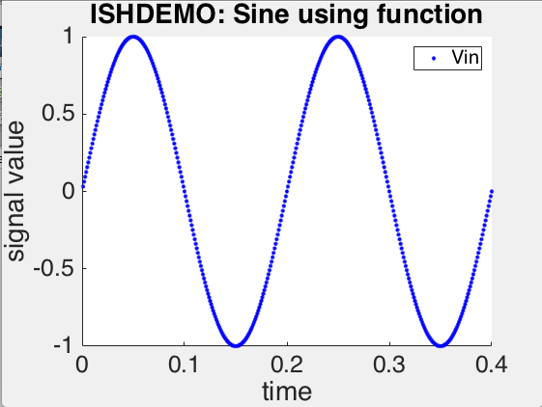

1. **Simulate filtering a square wave using an RC network in Matlab**

* Write your own Matlab function GenSquare(frequency, sampleRate and duration) to produce a unity amplitude square wave signal.
* Note you need so save the function in its own file named GenSquare.m and then call it from another script.
* To specify its output signal, pass it the parameters frequency, sampleRate and duration.
* Hint: Sensible values would be something like
* sampleRate = 1000Hz,
* frequency = 5Hz
* duration=0.4s.
* Plot the data signal against time to test your function
* Now consider the following RC circuit:

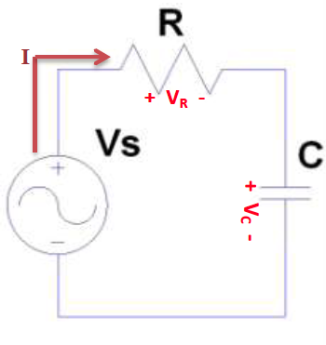

* The first order differential equation that describes voltages in this RC circuit is given by:



 

* Write your own Matlab function SimulateRC and pass is suitable parameters. It is required to simulate the voltage across the capacitor in terms of the applied voltage by using Euler’s samplewise recursive relationship to solve this equation:
* 
* Where:
* Vc(k+1) is the voltage across the capacitor at sample step k+1
* Vc(k) is the voltage across the capacitor at sample step k
* Vs(k) is the voltage applied to the RC network at time step k
* *h* is the temporal step size between two adjacent sample points
* R is the resistance in the circuit in Ohms
* C is the capacitance in the circuit in Farads
* Choose suitable values for R and C for your simulation to give a time constant of the order of 100ms.
* Make sure you write a title, put on a plot legend and label the axes.
* Plot the input and capacitor voltages against time, as shown below.

